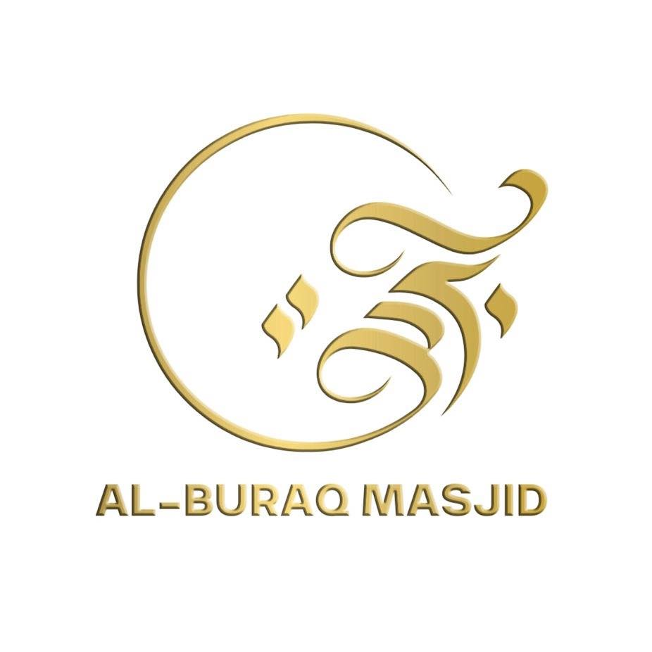

AL-BURAQ EDUCATION CENTRE

Staff Conduct Policy

STAFF CONDUCT POLICY
Al-Buraq Education Centre
1. Introduction
This Staff Conduct Policy outlines the expected standards of behaviour for all staff and volunteers at Al-Buraq Education Centre. Our aim is to ensure a safe, respectful, and professional environment for children, young people, parents, staff, and the wider community.
All staff must act as positive role models and uphold the values of the Centre at all times.

2. Professional Behaviour
All staff and volunteers must:
- Treat all children and adults with respect, kindness and fairness.
- Maintain professional boundaries at all times.
- Use appropriate language, tone, and behaviour.
- Dress in a modest, respectful, and culturally appropriate manner when on premises.
- Be punctual and reliable for all sessions.
- Ensure mobile phones are switched off or silent and not used during teaching time except for emergencies.

3. Safeguarding Responsibilities
All staff must:
- Follow the Safeguarding and Child Protection Policy at all times.
- Report any concerns immediately to the Designated Safeguarding Lead.
- Never promise confidentiality to a child.
- Never be alone in a closed room with a child. Doors must remain open or have visibility panels.
- Never use physical punishment or aggressive behaviour.

4. Interaction With Children
Staff and volunteers must:
- Maintain appropriate distance and boundaries.
- Give praise, encouragement, and correction in a positive, respectful manner.
- Avoid any behaviour that could be misinterpreted as inappropriate.
- Ensure any physical contact is necessary, appropriate, and transparent (e.g., first aid).

5. Teaching Conduct
Staff must:
- Prepare lessons appropriately and teach to the best of their ability.
- Supervise children at all times during their session.
- Encourage good behaviour through positive reinforcement.
- Never belittle, shout at, or humiliate a child.

6. Confidentiality
- Staff must respect confidentiality and only share information on a need-to-know basis.
- Personal information must never be shared or discussed outside the Centre.

7. Use of Social Media
Staff must:
- Not communicate with children or parents through personal social media accounts.
- Not share photos of children without official consent and management approval.
- Uphold professionalism on all platforms.

8. Health & Safety
Staff must:
- Follow all health and safety procedures.
- Report hazards or concerns immediately.
- Participate in required training.

9. Conduct Outside the Centre
Staff behaviour outside of work must not bring the Centre into disrepute.
Any behaviour that risks the reputation of the Centre may be addressed through disciplinary procedures.

10. Breaches of Conduct
Failure to follow this policy may result in:
- Verbal or written warnings
- Suspension or removal from role
- Referral to safeguarding authorities if needed

11. Declaration
All staff and volunteers must sign the Policy Agreement Form to confirm they have read, understood, and will follow this policy.

