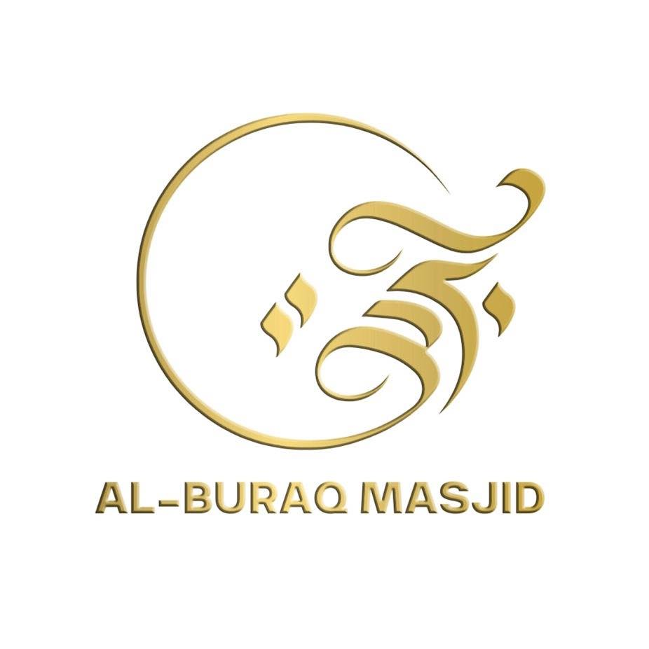

AL-BURAQ EDUCATION CENTRE

Behaviour Policy

1. Introduction
Educational excellence, Islamic character and community service form the foundation of our approach to behaviour management at the Centre.
At the heart of our mission is the belief that every learner can achieve exceptional progress in both knowledge and conduct when guided through Islamic values of respect, honesty, and patience.
We expect behaviour to be exemplary—rooted in sincerity, compassion and self-discipline. Pupils behave well because they understand its moral value in Islam, not merely because they are told to.
By promoting adab (good manners) and respect, we nurture confident and self-assured learners who take pride in their achievements and contribute positively to the Centre environment.
2. Aims
Ensure every pupil feels safe, respected and valued.
Promote Islamic character, humility and responsibility.
Maintain a peaceful and disciplined learning atmosphere.
Apply clear, consistent behaviour procedures for all staff and volunteers.
Work closely with parents to support positive conduct.
Prevent bullying, racism, and any form of discrimination.
Reflect the Centre’s mission to combine Islamic and academic excellence.
3. Responsibilities
3.1 Leadership
Overall responsibility for this policy lies with the Head of Education and the Mosque Management Committee, who ensure it is reviewed and implemented effectively.
3.2 Staff
All teachers, tutors and volunteers are expected to model patience, fairness and kindness, supporting one another in maintaining discipline and respect.

3.3 Parents and Pupils
A positive Centre environment depends on cooperation between home and mosque. All parties must uphold the Centre’s shared values and rules.
4. What Pupils Can Expect from Staff
Lessons that begin promptly and are well-prepared.
Encouragement and praise for effort and improvement.
Fair, respectful and consistent treatment.
A safe, organised and caring learning space.
Confidentiality and understanding.
Calm conflict resolution and equal respect for all learners.
Teachers who model good Islamic manners and conduct.
5. What Staff Can Expect from Pupils
Arrive on time, ready to learn and participate.
Greet teachers and peers with respect.
Follow mosque rules and instructions immediately.
Use polite and positive language.
Treat the Qur’an, books and property with care.
Take responsibility for their actions and learning.
Avoid disrupting lessons or disrespecting others.
Represent the Centre positively within the community.
6. What Staff Can Expect from Parents
Respectful communication and cooperation.
Ensure punctual attendance and suitable Islamic attire.
Support the Centre’s behaviour expectations.
Address concerns calmly and privately.
Encourage good manners and regular attendance at home.
Inform staff of any personal issues that might affect behaviour.
7. Leadership and Behaviour Oversight
The Head of Education and Centre Management Team oversee discipline.
Behaviour incidents are logged, monitored and reviewed termly.
Leadership supports staff wellbeing and ensures fairness in decisions.
Persistent or serious misconduct is addressed promptly and proportionately.
8. Setting Expectations
The Centre’s rules and Islamic values are displayed in every classroom.
Pupils and parents are briefed on the Code of Conduct.
The Home–Centre Agreement outlines mutual responsibilities.
All staff are authorised to address misconduct respectfully.
Positive behaviour is promoted through rewards and praise.
9. Classroom Management
Lessons should be engaging, purposeful and respectful.
Pupils are seated strategically for focus and cooperation.
A Reflection Area is available for calm time or quiet prayer.
Teachers maintain calm authority and consistent routines.
Disputes are resolved peacefully, focusing on learning from mistakes.
10. Rewards and Recognition
Verbal praise (e.g. “Excellent effort”, “JazakAllah khair”).
Stickers, merits, or certificates for good conduct.
Mentions during Friday assembly or newsletters.
“Good Character” awards each term for kindness or helpfulness.
Positive phone calls or notes sent home to parents.
11. Sanctions and Consequences
Behaviour that breaches expectations will be dealt with fairly and consistently:
Verbal reminder – gentle correction.
Warning – clear explanation of next step.
Reflection time – short removal from class to think and refocus.
Loss of privilege – such as play or activity time.
Written warning / parent contact.
Behaviour Support Plan – personalised improvement plan.
Meeting with Head of Education or Mosque Manager.
Suspension / exclusion – only for serious misconduct.
12. Behaviour Support Plans
If repeated issues occur:
A personalised Behaviour Support Plan is created.
Targets are agreed with pupil and parent.
Weekly reviews track progress and improvements.
Plans focus on reflection, repentance and self-control.
13. Serious or Persistent Misconduct
Examples include:
Bullying, threats or intimidation.
Physical or verbal aggression.
Vandalism or damage to property.
Persistent refusal to follow rules.
Use of offensive language or gestures.
Bringing prohibited items to the Centre.
Serious cases are referred to the Head of Education and logged formally.
14. Reflection and Temporary Removal

For serious disruption, pupils may spend time in a Reflection Area.
This allows them to calm down, complete work quietly and consider their actions.
Parents are informed if this occurs frequently.
15. Suspension and Exclusion
Authorised only by the Head of Education / Mosque Manager.
Parents receive written notice explaining reasons and duration.
Work may be set to complete at home.
A reintegration meeting is held before return.
Permanent exclusion is a last resort for extreme behaviour endangering others or repeatedly disrupting learning.
16. Behaviour Monitoring and Records
All incidents and rewards are recorded in the Behaviour Log.
The Education Coordinator reviews data each half-term.
Parents are informed early if patterns of concern appear.
17. Teaching Good Manners and Islamic Conduct
At Al-Buraq Education Centre, we understand that Islamic character (akhlaaq) is not just an educational goal, but a lifelong responsibility tied to faith. The Prophet Muhammad (peace be upon him) said:
❝ I was sent only to perfect good character. ❞ (Musnad Ahmad)
We recognise that behaviour reflects inner belief and is a form of da’wah. Our teaching of Islamic conduct is therefore proactive, consistent and rooted in love for the deen.
🟢 Key Principles We Promote:
- **Respect for authority**: Respecting parents, teachers, and elders is obligatory. The Qur’an reminds us: “And lower to them the wing of humility out of mercy…” (17:24).
- **Truthfulness and honesty**: The Prophet (peace be upon him) said: “Truthfulness leads to righteousness, and righteousness leads to Paradise…” (Bukhari & Muslim).
- **Cleanliness and self-respect**: “Truly, Allah loves those who turn to Him and those who purify themselves.” (2:222)
- **Forgiveness and patience**: “And those who restrain anger and pardon people – and Allah loves the doers of good.” (3:134)
- **Controlling the tongue**: Learners are taught to avoid gossip, lying, backbiting and foul language.
- **Fulfilling trusts**: Being on time, completing tasks, and taking care of belongings are emphasised.
🟢 How We Teach These Values:
- **Dedicated weekly Islamic Character lessons**, tailored to age groups.
- **Prophetic storytelling**: Using Seerah and stories of the Sahabah (RA) to model real behaviour.
- **Assembly topics**: Weekly themes such as sabr (patience), shukr (gratitude), amanah (trust), and tawakkul (reliance on Allah).
- **Qur’anic verses and Hadith wall displays** in every classroom to inspire moral actions.
- **Du‘a and reflection time**: Learners are encouraged to seek forgiveness, make intention (niyyah), and reflect on their actions in light of deen.
- **Good Character Awards** are linked to Islamic virtues: honesty, humility, compassion, and diligence.
🟢 Daily Practices:
- Learners begin sessions with **Bismillah** and end with **du‘a**.
- Opportunities for **Salah, Wudu**, and **Qur’an recitation** are embedded in routines.
- Islamic greetings (Assalamu Alaikum) and good manners are consistently modelled by staff.
In all things, learners are reminded that good character is the weightiest thing on the scales on the Day of Judgment, as stated in the hadith:
❝ Nothing will be heavier on the Day of Resurrection in the scale of the believer than good character. ❞ (Tirmidhi)
Our goal is not just discipline, but the nurturing of young Muslims who uphold Islamic ethics with sincerity, wisdom and love for Allah ﷻ.
Children are taught that good behaviour is part of faith.
Regular lessons, stories of the Prophets (peace be upon them), assemblies and classroom discussions promote:
Respect for elders and teachers.
Patience, honesty and forgiveness.
Cooperation, cleanliness and humility.
Responsibility for personal choices and actions.
18. Anti-Bullying Commitment
The Centre has zero tolerance for bullying or racism.
Every report is investigated confidentially and swiftly.
Victims are supported; those responsible receive guidance and appropriate sanctions.
Parents are always informed.
The Centre follows the Al-Buraq Anti-Bullying Policy.
19. Trips and Events
Pupils represent the mosque during visits and events and must display exemplary behaviour and Islamic manners.
Parents are briefed before trips, and serious misbehaviour may lead to exclusion from future outings.
20. Staff Support and Training
The Head of Education ensures that:
All staff receive behaviour management training.
Volunteers attend induction sessions.
Staff are supported in challenging situations.
Wellbeing is monitored and valued.
21. Safeguarding and Behaviour
Behavioural changes can signal distress or abuse.
Staff must report concerns immediately to the Designated Safeguarding Lead (DSL).
All actions follow the Safeguarding and Child Protection Policy.
22. Allegations against Staff
Allegations of misconduct are reported directly to the Head of Education and Local Safeguarding Authority.
False or malicious allegations are treated seriously and may result in disciplinary action.
23. Reasonable Force
Trained staff may use minimum, proportionate force only to prevent injury, serious disruption or property damage.
All incidents must be recorded and reviewed.
24. Searching and Confiscation
Staff may search pupils or belongings if they suspect prohibited items such as:
Weapons or sharp objects
Drugs, alcohol or tobacco
Stolen or inappropriate items
Offensive media or materials
Items may be confiscated and returned at the discretion of the Mosque Manager. Illegal items will be handed to the police.
25. Monitoring, Evaluation and Review
This policy will be promoted and applied throughout the Centre.
Governors and Management review its operation annually.
Formal review takes place every two years—next due November 2027.

Appendix 1 – Behaviour Management Flowchart
Stage | Action | Responsible Person | Parent Involvement
1. Reminder | Calm verbal correction based on Islamic values. | Class Teacher | None required
2. Warning | Clear warning and explanation of consequence. | Class Teacher | Optional note home
3. Reflection | Short time out for pupil to calm and reflect. | Teacher / Assistant | Notified verbally
4. Behaviour Log Entry | Record incident and discuss improvement. | Teacher | Parent informed
5. Management Referral | Escalate to Head of Education. | Management Team | Parent meeting arranged
6. Support Plan | Develop written Behaviour Support Plan. | Education Coordinator | Parent signs plan
7. Suspension / Exclusion | For severe or unsafe conduct. | Head of Education | Formal letter and meeting

Appendix 2 – Behaviour Report Card
Pupil Name: ___________________________
Date Issued: ___________________________
Teacher: ___________________________
Date | Session | Target / Focus | Comment / Parent Initials
Review Outcome: ☐ Improved ☐ Continue ☐ Escalate

Appendix 3 – Incident & Sanction Record
Date & Time | Location
Pupil(s)
Description of Incident
Immediate Action
Follow-Up / Sanction
Parent Notified | By
Recorded By: ___________________ Reviewed By: ___________________

Appendix 4 – Rewards & Sanctions Summary
Positive Behaviour Rewards
Positive Behaviour | Reward
Good manners and respect | Verbal praise / certificate
Helping others | Mention in assembly
Excellent effort or attendance | Merit / sticker / note home
Qur’an or Islamic Studies progress | Certificate or small prize
Leadership and kindness | “Good Character” Award
Misconduct Consequences
Type of Misconduct | Consequence
Low-level disruption | Reminder / warning
Disrespect or lateness | Reflection time
Repeated misbehaviour | Written warning / plan
Bullying or aggression | Parent meeting / suspension
Serious offence (violence, damage) | Exclusion / possible police referral

Appendix 5 – Policy Review Log
Review Date | Reviewed By | Summary of Changes / Notes | Next Review Due
November 2025 | Head of Education | First publication | November 2027
November 2027

As an Islamic education centre, our standards of behaviour are not only guided by educational best practice but by the values found in the Qur’an and Sunnah. We strive to cultivate a learning atmosphere that reflects the akhlaaq (character) of the Prophet Muhammad (peace be upon him), where mercy, justice and humility are nurtured alongside academic progress.
Our aims are shaped by the responsibility placed upon educators in Islam: to be role models, to uphold the rights of the learner, and to promote a safe, dignified environment rooted in the remembrance of Allah (dhikr), mutual respect and ihsaan (excellence in conduct).
In line with Islamic guidance, staff are expected to treat pupils with rahmah (compassion), fairness and respect, as exemplified by the Prophet (peace be upon him) in his treatment of both children and students of knowledge.
Pupils are reminded that learning is an act of worship (‘ibadah) and that good behaviour is a reflection of their sincerity (ikhlas) and commitment to Islamic character. They are encouraged to respect knowledge and those who impart it.

