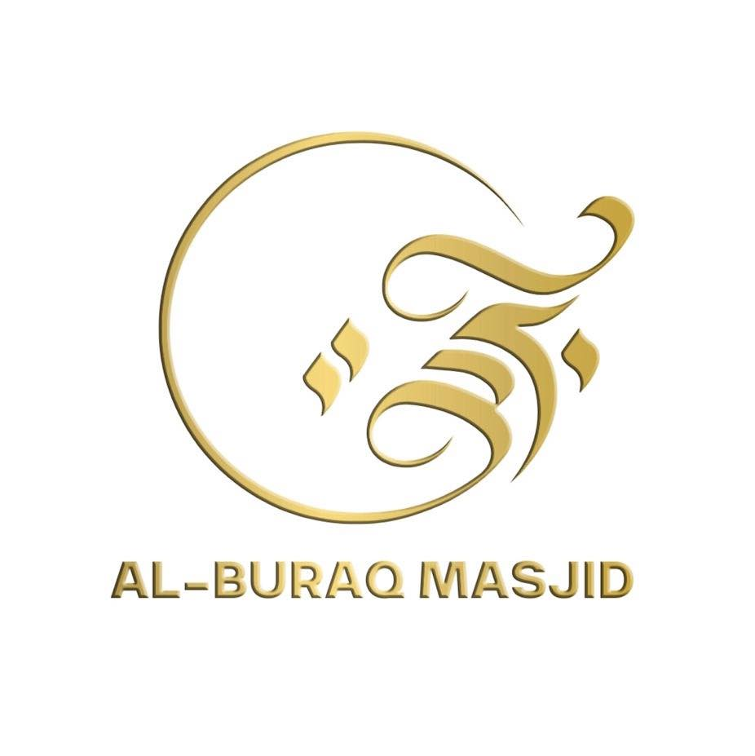

AL-BURAQ EDUCATION CENTRE

E-Safety Policy

Introduction

E-Safety Statement
E-Safety encompasses Internet technologies and electronic communications such as mobile phones, tablets, gaming devices, and wireless technology. It highlights the need to educate children, young people, staff, and parents about both the benefits and the potential risks of using new technologies. The purpose of this policy is to promote responsible, respectful, and safe use of digital tools in accordance with Islamic values.
The Mosque’s E-Safety Policy will operate in conjunction with other key policies including those for Pupil Behaviour, Anti-Bullying, Data Protection, Safeguarding, and Staff Code of Conduct. Together, these ensure that all members of our community are protected from online harm and guided towards the correct use of technology for learning and communication.
We aim to teach children to use the Internet safely and positively — to verify information, avoid inappropriate content, protect personal data, and communicate respectfully online. Staff will receive training to identify signs of online risks such as cyberbullying, exploitation, exposure to inappropriate material, or contact with strangers, and will act immediately following safeguarding procedures.
Parents and carers are encouraged to work in partnership with the mosque by monitoring children’s online activity at home and promoting safe habits such as privacy awareness, screen-time balance, and kindness in digital interactions.
Islamic Reminder:
“Whoever believes in Allah and the Last Day, let him speak good or remain silent.”
(Sahih al-Bukhari, Muslim)
This Hadith reminds us that our words — whether spoken or typed — carry responsibility. The mosque community is therefore committed to nurturing digital citizens who use technology wisely, respectfully, and in the service of goodness.

Good Habits
E-Safety depends on effective practice at several levels within the mosque community. Building good habits in the use of digital technology is essential to ensure that children, staff, and families benefit from technology safely and responsibly.
To achieve this, the mosque will ensure:
- Responsible ICT use by all staff, volunteers, and pupils — encouraged through education, supervision, and reinforced through clearly published policies.
- Sound implementation of the E-Safety Policy in both administration and the curriculum, including a secure mosque network design, restricted access, and regular system monitoring.
- Signing of the ‘Acceptable Internet Use Policy’ by all staff members to confirm their understanding and commitment to safe and responsible practice.
- Use of approved mosque ICT software and systems only, with filtering and security measures in place to prevent misuse or exposure to harmful content.
- Education of pupils through E-Safety sessions timetabled within the curriculum, focusing on topics such as online respect, privacy, cyberbullying awareness, and the Islamic ethics of digital communication.
- Regular review and training, ensuring that staff and volunteers are up to date with new technologies, online trends, and safeguarding risks.
The mosque has appointed an E-Safety Coordinator, who will also serve as the Designated Safeguarding and Child Protection Officer, as these roles naturally overlap. This person will take the lead in promoting digital safety, reviewing policies, delivering staff training, and managing any incidents or concerns related to online safety.
Islamic Reflection:
“Do not pursue that of which you have no knowledge. Indeed, the hearing, the sight, and the heart — all of those will be questioned.”
(Qur’an 17:36)
This verse reminds us that responsible use of technology requires awareness, self-control, and accountability before Allah for what we view, share, and say online.

Why is Internet Use Important?

The purpose of Internet use at Al-Buraq Education Centre is to raise educational standards, to promote pupil achievement, to support the professional work of staff and to enhance the Mosque’s management information and administration systems.

Internet use is part of the curriculum and a necessary tool for learning. It is an essential element in 21st century life for education, business and social interaction. Access to the Internet is therefore an entitlement for pupils who show a responsible and mature approach to its use. Our Mosque has a duty to provide pupils with quality and appropriate internet access.

Pupils will use the Internet outside mosque and will need to learn how to evaluate Internet information and to take care of their own safety and security.

How does Internet Use Benefit Education?

Benefits of using the Internet in education include:

- Access to world-wide educational resources including museums and teaching resources;
- Educational and cultural exchanges between pupils world-wide;
- Access to experts in many fields for pupils and staff;
- Professional development for staff through access to national developments, educational materials and effective curriculum practice;
- Collaboration across support services and professional associations;
- Improved access to technical support including remote management of networks and automatic system updates;

How can Internet Use Enhance Learning?

- The Mosque Internet access will be designed expressly for pupil use and includes filtering appropriate to the age of pupils.
- All ABEC staff are trained on how to monitor student’s internet access
- Pupils will be taught what Internet use is acceptable and what is not and given clear objectives for Internet use.
- Internet access will be planned to enrich and extend learning activities.
- Staff should guide pupils in on-line activities that will support learning outcomes planned for the pupils’ age and maturity.
- Pupils will be educated in the effective use of the Internet in research, including the skills of knowledge location, retrieval and evaluation.

Authorised Internet Access

- The Mosque will maintain a current record of all staff and pupils who are granted Internet access.

- All staff must read and sign the ‘Acceptable ICT Use Agreement’ before using any mosque ICT resource.

- Parents will be informed that pupils will be provided with supervised Internet access.

World Wide Web

- If staff or pupils discover unsuitable sites, the URL (address), time, content must be reported to the Deputy Principal or Principal.
- ABEC will ensure that the use of Internet derived materials by pupils and staff complies with copyright law.
- Pupils should be taught to be critically aware of the materials they are shown and how to validate information before accepting its accuracy.

Email

- The staff mosque email system is hosted by google mail.
- ABEC does not currently provide ‘in-house’ email facilities for our pupils.
- Pupils are not allowed to check any personal email accounts within the ICT suite and these sites can indeed be blocked by staff, thereby ensuring our PC’s are not harmed by any external viruses.
- Users are responsible for all e-mail sent and for contacts made that may result in email being received, professional conduct when sending emails using a mosque e-mail address is expected at all times.
- As e-mail can be forwarded or inadvertently be sent to the wrong person, the same professional levels of language and content should be applied as for letters or other media at all times;
- Posting anonymous messages and forwarding chain letters is forbidden;

Social Networking

- At ABEC access to social networking sites and newsgroups are currently available but controlled by the teacher’s use.
- Pupils, though advised not to use social networking sites, either at mosque or indeed at home, are however advised never to give out personal details of any kind which may identify them or their location.
- Pupils are advised not to place personal photos on any social network space.

Internet Filtering

The mosque filters undesired material through a DNS Filter Network System. The on-going success is reviewed termly by the safety coordinator.

Managing Emerging Technologies

- Emerging technologies will be examined for educational benefit and a risk assessment will be carried out before use at ABEC is allowed.
- Pupils are not allowed to bring or therefore use mobile phones for personal use during lessons or formal mosque time. The sending of abusive or inappropriate text messages is forbidden.
- Staff are not allowed to use their mobile phones either in class, or whilst walking around the mosque.

Published Content and the Mosque Web Site

ABEC maintains to follow our existing e-safety standards:

- The contact details on the Web site should be the mosque address, e-mail and telephone number. Staff or pupil’s personal information will not be published.
- The Principal will take overall editorial responsibility and ensure that content is accurate and appropriate.

Publishing Pupils’ Images and Work

- Photographs that include pupils will be selected carefully and will not enable individual pupils to be clearly identified.
- Pupils’ full names will not be used anywhere on the Web site or Social Media, particularly in association with photographs.
- Written permission from parents or carers will be obtained before photographs of pupils are published on the mosque Web site.

Information System Security and Virus Protection

- Mosque ICT systems capacity and security will be reviewed regularly.
- Virus protection will be installed and updated regularly. The PC’s in the ICT suite have been recently reviewed and reinstalled with ‘Anti-Virus and Malware Protection’.
- Staff laptops and PC’s in the main building of the mosque are protected by ‘Microsoft Security Essentials’, set to run a virus scan once weekly. This scan is regularly reviewed by the ICT coordinator.
- Newer computers have Norton Anti-Virus installed on them.

Protecting Personal Data

Personal data will be recorded, processed, transferred and made available according to the Data Protection Act 1998.

Assessing Risks - on-going

- The Mosque will take all reasonable precautions to prevent access to inappropriate material. However, due to the international scale and linked Internet content, it is not possible to guarantee that unsuitable material will never appear on a mosque computer. No internet content filtering system is 100% secure due to the ever changing nature of undesirable sites, virus or material.
- The mosque should audit ICT use to establish if the e-safety policy is adequate and that the implementation of the e-safety policy is appropriate.

Handling e-safety Complaints

- Complaints of Internet misuse will be dealt with by a senior member of staff.
- Any complaint about staff misuse must be referred to the head teacher or deputy head teacher.
Complaints of a child protection nature must be dealt with in accordance with mosque child protection procedures.
Pupils and parents will be informed of the complaints procedure.

Communication of Policy

Pupils
- Rules for Internet access will be posted in all networked rooms.
- Pupils will be informed that Internet use will be monitored.

Staff
- All staff will be given the Mosque e-Safety Policy and its importance explained.
- Staff should be aware that Internet traffic can be monitored and traced to the individual user. Discretion and professional conduct is essential.

Parents
- Parents’ attention will be drawn to the Mosque e-Safety Policy in newsletters, the Mosque brochure and on the mosque Web site.

ABEC E-Safety Rules

These e-Safety Rules help to protect pupils and the mosque by describing acceptable and unacceptable computer use.

- The mosque owns the computer network and can set rules for its use.
- It is a criminal offence to use a computer or network for a purpose not permitted by the mosque.
- Irresponsible use may result in the loss of network or Internet access.
- Network access must be made via the user’s authorised account and password, which must not be given to any other person.
- All network and Internet use must be appropriate to education.
- Copyright and intellectual property rights must be respected.
- Messages shall be written carefully and politely, particularly as email could be forwarded to unintended readers.
- Anonymous messages and chain letters are not permitted.
- Users must take care not to reveal personal information through email, personal publishing, blogs or messaging.
- The mosque ICT systems may not be used for private purposes, unless the head teacher has given specific permission.
- Use for personal financial gain, gambling, political activity, advertising or illegal purposes is not permitted.

The mosque may exercise its right to monitor the use of the mosque’s computer systems, including access to web-sites, the interception of e-mail and the deletion of inappropriate materials where it believes unauthorised use of the mosque’s computer system may be taking place, or the system may be being used for criminal purposes or for storing unauthorised or unlawful text, imagery or sound.

AL-BURAQ EDUCATION CENTRE (ABEC)

Information Systems Code of Conduct
To ensure that all staff are fully aware of their professional responsibilities when using information and communication technology (ICT) systems, they are required to read and sign this Code of Conduct in conjunction with the ‘Acceptable Internet Use Policy’. Staff should also consult the Mosque’s E-Safety Policy for further guidance and clarification.

Professional Responsibilities
• The information systems are the property of the mosque, and I understand that it is a criminal offence to use a computer for a purpose not permitted by its owner.
• I will ensure that my use of information systems is consistent with my professional role and the values of the mosque.
• I understand that mosque information systems must not be used for private or personal purposes without specific permission from the Head Teacher or Centre Manager.
• I understand that the mosque reserves the right to monitor my use of its systems, including email and internet access, to ensure compliance with policy and safeguarding standards.
• I will respect system security and will not disclose any passwords or access details to anyone other than an authorised system manager.
• I will not install any software, apps, or hardware without prior permission.
• I will ensure that personal and confidential data is kept secure, handled appropriately, and only accessed by authorised persons, whether in the mosque, taken off-site, or accessed remotely.
• I will respect copyright, data protection, and intellectual property rights when creating, copying, or distributing materials.
• I will immediately report any incidents or concerns relating to the safety of children, data breaches, or misuse of technology to the E-Safety Coordinator or Designated Safeguarding Lead (DSL).
• I will ensure that all electronic communication with pupils, parents, or external contacts is professional, transparent, and appropriate.
• I will promote digital safety and responsibility among the pupils in my care and will encourage positive use of technology in accordance with Islamic manners and mosque policies.

Monitoring and Enforcement
The mosque reserves the right to monitor the use of its ICT systems, including Internet activity, email communications, and stored materials. The mosque may intercept or delete any unlawful or inappropriate content if it suspects that the system is being misused, used for criminal purposes, or for storing unauthorised material such as harmful text, images, or sound files.

Islamic Reflection
“Indeed, the hearing, the sight, and the heart — all of those will be questioned.”
(Qur’an 17:36)
This verse reminds us that we are accountable before Allah for what we view, share, and communicate. As educators and role models, it is our duty to use technology with integrity, modesty, and sincerity — setting the best example for our learners.

I have read, understood and agree with the Information Systems Code of Conduct.

Signed: ……………………………………………………………………….. Date: ………………………………

