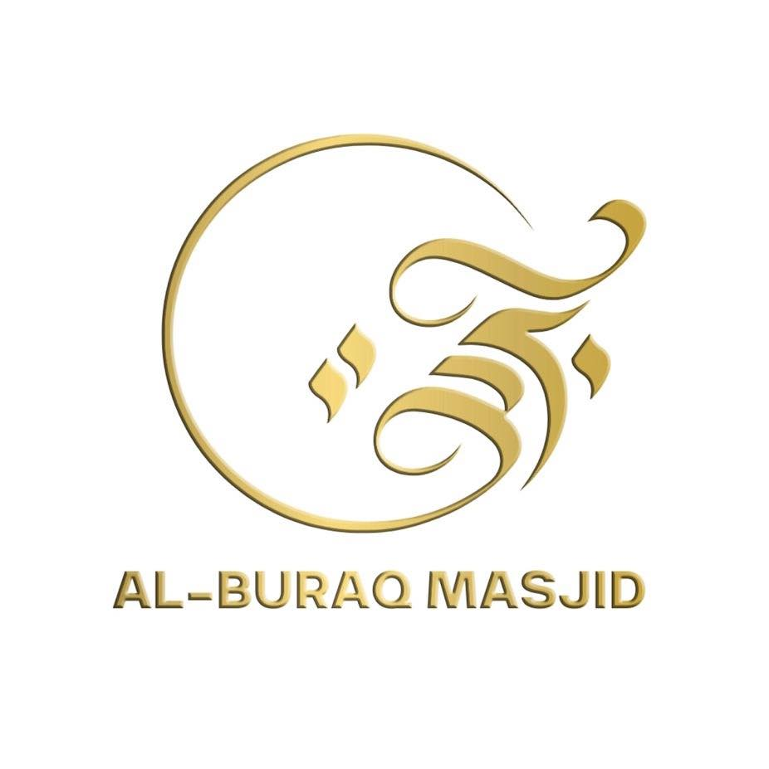

AL-BURAQ EDUCATION CENTRE

Equal Opportunities
Policy

Equal Opportunities Policy

Introduction:

Equal Opportunities Policy
At Al-Buraq Education Centre, we aim to promote a positive and welcoming culture where discrimination is not tolerated. This policy has been drawn up to reflect our commitment to ensuring the unbiased treatment that pupils, employees and prospective employees are entitled to expect. We believe that every individual has the right to be valued, respected and offered equal opportunities, access and treatment, regardless of race, colour, ethnic origin, nationality, sex, religion, gender, marital status, age, disability or sexuality.
“O mankind! We created you from a single male and female and made you into nations and tribes so that you may know one another. Verily, the most honourable of you in the sight of Allah is the most righteous of you.”
(Qur’an 49:13)
We strive to uphold these Islamic principles of equality and justice in all our practices, ensuring that every member of our mosque community feels valued, supported and able to achieve their potential.

This policy draws on legislation ranging from the Sex Discrimination Act 1975 to the Equality Act 2010, which requires mosque, both to avoid discrimination and to promote equality for pupils, staff and others using mosque facilities. It sets out how our mosque complies with this legislation.

Definitions of discrimination:

Under the law, there are different categories of discrimination, with differences in the legal framework surrounding them.

These are:

- Direct discrimination: This is unlawful for all protected grounds except, in some circumstances, age and disability in Mosques. Direct Discrimination is when a person is treated less favourably than others in comparable circumstances because of a special characteristic such as sex, race or a disability. In the case of direct age discrimination, this is unlawful only if it cannot be objectively justified.

- Indirect Discrimination: In essence, this occurs when a provision, criterion or practice is applied equally to all but have a different impact on members of one or more protected groups, placing them at a disadvantage as a result. Indirect discrimination is unlawful unless it can be justified for reasons unrelated to the characteristic in question. (An example might be a physical strength test, which would discriminate against women, and which might be justified in relation to a job necessitating heavy lifting, but not in relation to teaching.)

- Victimisation – This involves treating a person less favourably because they have taken action in respect of discrimination, e.g. by bringing a complaint or giving evidence for a colleague. This is also unlawful.

- Harassment – This refers to unwanted conduct which violates a person’s dignity or creates an intimidating, hostile, degrading, humiliating or offensive environment for them, on grounds of one of the relevant characteristics such as sex or race. It is also unlawful in many of the situations covered by discrimination law.

Employment:

Our Mosque does not discriminate in the employment of staff on grounds of gender, sexual status, race, disability, sexual orientation, religion, belief or age. This includes discrimination in relation to recruitment, terms and conditions, promotions, transfers, dismissals, training and employment practices such as dress codes and disciplinary procedures.

With regard to disability, we aim to make such reasonable adjustments as are necessary to prevent a disabled person being at a substantial disadvantage in comparison with people who are not disabled.

We are an equal opportunities employer. The management committee will:

- Provide equal opportunities to any employee or job applicant and will not discriminate either directly or indirectly.
- Ensure staff are treated as equitably as paid staff, having regard to national and local conditions of service and to statute.

To meet these objectives management will ensure that: -

- Selection criteria relate to job requirements and are not discriminatory by asking for inappropriate qualifications or experience.
- Job descriptions, advertisements and personnel specifications are not discriminatory.
- Every job is open equally to all applicants who meet the required criteria.
- Applications will be dealt with in accordance with appropriate procedures.
- Promotion and training is open equally to all eligible employees and selection criteria do not exclude applicants from any group.

All staff has the right to Continuing Professional Development, and Performance Management Reviews, as detailed in our CPD and PM policies, and should have access to relevant information.

Duty to promote equality:

Race:

Our mosque is racially diverse and this is valued by all sectors of our mosque community. This racial diversity enriches the experience of all at our mosque. We actively promote equality of opportunity and good relations between persons of a different race and nationality.

Discrimination is tackled and not tolerated.

As part of our on-going assessments and tracking we will monitor the levels of pupil attainment and achievement for different groups of pupils, including racial groups.

Action is taken as appropriate.

To provide equal opportunities for all races and promote good race relations we will:

- acknowledge that our society is culturally diverse and develop an appropriate, multicultural Islamic curriculum and environment
- challenge racist remarks and respond in an appropriate manner. All offences must be reported to the principal
- record and report racist remarks as required by the mosque.
- ensure that books and resources reflect a wide range of cultures in a positive way
- monitor and address any differences between racial groups in their attainment levels and achievement
- value all languages and see multi-lingual’s as an asset
- respect the dress requirements of the religion, taking account of safety regulations across the curriculum
- promote an understanding and respect of different cultures within our society
- invite visitors from other cultures into mosque whenever possible.

Gender:

We aim to provide equal opportunities for both sexes.

To achieve this, we will:
- monitor the achievement and progress of boys and girls as part of our ongoing tracking and take action to address any identified issues
- carefully select books, equipment and teaching materials to avoid gender bias and stereotyping
- be aware of using gender as a means of organisation – e.g. in registers, for grouping, when lining up etc.
- show disapproval of sexist remarks and respond in an appropriate manner
- give positive encouragement to both sexes to participate in all activities and to work and play freely with others
- take account of the interests and concerns of both boys and girls when planning activities and allow for a variety of outcomes to accommodate both sexes. This includes in mosque and out of mosque’s activities
- have equally, high expectations of both boys and girls
- recognise the possibility of gender bias in our teaching styles
- ensure that rewards and sanctions, the recognition of achievement and the delegation of responsibility are all offered equally to both sexes
- take note of relevant research and advice concerning gender issues
- encourage more male visitors and helpers into mosque to provide a balance of role models for all children.

Disability:

We aim to recognise and provide for the needs of both children and adults with physical or learning disabilities, giving them equal opportunities within our mosque.

To achieve this, we will:

- welcome anyone with a disability into our mosque– both children and adults
- be knowledgeable about the disabilities or special needs of any child in our care
- facilitate the fullest possible participation of pupils with disabilities or particular needs and maximum access to activities provided
- be aware of the special provision required by some children with disability and make every effort to provide it
- foster an understanding of disability within the mosque.
- ensure equal access and opportunity for visitors with disabilities and encourage them to visit or help in mosque.

Roles

Management Committee:

The management committee has set out its commitment to equal opportunities in this policy statement, and it will continue to do all it can to ensure that all members of the mosque community are treated fairly and with equality.

The management committee seeks to ensure that people with disabilities are not discriminated against when applying for jobs at our mosque. The management committee will take all reasonable steps to ensure that the mosque environment gives access to people with disabilities.

The management committee ensures that no child is discriminated against whilst in our mosque on account of their sex, religion or race. All children will have access to the full range of the curriculum, and regulations regarding mosque uniform will be applied equally to boys and girls.

If a child’s religion affects the mosque’s uniform, then the mosque will deal with each case sensitively and with respect for the child’s cultural traditions.

The role of the Principal:

It is the Principal’s role to implement the mosque’s equality and anti-racist policies and is supported by the management committee in so doing.

It is the Principal’s role to ensure that all staff are aware of the mosque policy on equal opportunities, and that teachers apply these guidelines fairly in all situations.

The Principal ensures that all appointment panels give due regard to this policy, so that no one is discriminated against when it comes to employment or training opportunities.

The Principal promotes the principle of equal opportunity when developing the curriculum, and promotes respect for other people in all aspects of mosque life, for example, in the assembly, where respect for other people is a regular theme, and in displays shown around the mosque.

The Principal treats all incidents of unfair treatment and any racist incidents with due seriousness.

The role of the class teacher:

The class teacher ensures that all pupils are treated fairly, equally and with respect.

We do not discriminate against any child.

When selecting classroom materials, teacher’s pay due regard to the sensitivities of all members of the class and do not provide material that is racist or sexist in nature.

Teachers strive to provide material that gives positive images of ethnic minorities and that challenges stereotypical images of minority groups.

The Curriculum:

We aim for all children to fulfil their potential across a broad, rich and balanced curriculum.

To achieve this, we must promote equal opportunities. This will include:

- being aware of equal opportunities issues when planning and assessing all aspects of the curriculum
- treating children as individuals, recognising and meeting individual needs
- providing equal access to the curriculum and other aspects of mosque life, and facilitating the fullest possible participation of all children
- challenging myths, discrimination and stereotypes
- using materials which reflect social and cultural diversity and providing positive images of race, gender and disability.

Resources:

All books, materials and resources used in mosque will be chosen to avoid racial bias, sexual stereotyping, and must reflect as far as possible the diverse cultures of the society in which we live. Resources should positively reflect differences in race,

gender, ability, background, and religious belief. Care will be taken to ensure equal access to resources.

Monitoring:

Monitoring involves collecting data, analysing and assessing it to measure the Mosque’s performance and effectiveness, and then identifying how the mosque can improve. As part of our on-going commitment to mosque improvement, we have a programme for monitoring pupils’ performance and progress, attitude and attendance and then analysing the gathered data to identify trends.

The Principal is responsible, with the Leadership Team, for judging whether the outcomes of monitoring are affected by issues of equality and whether this policy is being put into practice consistently and effectively.

If differences are highlighted that may indicate some inequality in provision, opportunity or treatment, this will be investigated and addressed. The Principal will share any concerns identified and actions agreed with Governors.

Where applicable mosque policies will carry an equalities statement.

Breaches of the policy

All discriminatory incidents will be regarded as a serious matter. Sanctions for children will be set out in the mosque’s behaviour policy. Any example of discrimination by a member of staff will be treated as a serious disciplinary matter and dealt with in accordance with the mosque personnel procedures.
Page

