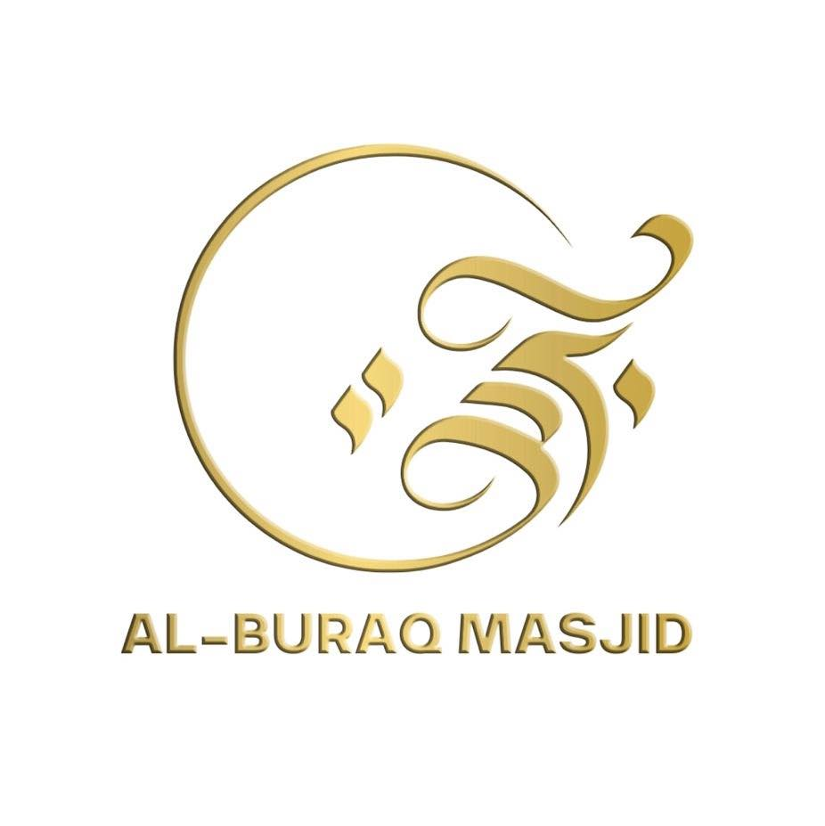

AL-BURAQ EDUCATION CENTER

Volunteer Policy

1. Introduction
The value of well-deployed volunteers in a mosque setting is widely recognised. At Al-Buraq Education Centre, volunteers play a vital role in supporting the work of teachers and staff, contributing meaningfully to pupil achievement and enhancing the overall learning environment.
The Principal and Head of HR believe strongly in the benefits of active parental and community involvement. By welcoming adults to participate in mosque life on a voluntary basis, we aim to foster well-planned, positive links between the mosque and the wider community.
It is important to emphasise that the role of volunteers is to enrich pupils’ educational experience, not to replace or interfere with the professional responsibilities of qualified teaching staff.
All volunteer participation—whether for a single day or on a longer-term basis—must be carefully planned and managed. Placement decisions should take into account the needs of both pupils and the staff involved, ensuring that volunteers are deployed in a way that is supportive, safe, and appropriate.
The Principal and Head of HR are committed to ensuring that volunteers complement, but do not replace, the roles of paid staff. Volunteers will not be assigned tasks that are typically the responsibility of salaried employees.

2. Mosque Policy
The Head of HR is responsible for ensuring that this policy provides a clear and consistent framework for the recruitment, engagement, and deployment of volunteers.
This document should be included in the staff handbook and made accessible to all relevant parties, including existing staff and new volunteers.
This policy will be reviewed regularly by the Head of HR and updated as needed to reflect changes in legislation, national guidance, or best practices related to volunteering in educational or religious settings.

3. Deployment

Volunteers should not be asked to carry out duties which:

- Fall normally within a teacher’s responsibility under loco parentis;
- Fall normally within the job description of a teacher or member of support staff,
i.e. they must not be asked to cover the absence of staff from mosque;
- Would normally be performed by a contractor engaged by the mosque;
- Require them to have unsupervised access to children;
- It should be noted that the Class Teacher remains responsible for the organisation of the class and methods of work;
- Expose them to dangerous or hazardous substances or situations.

3. Deployment and Induction of Volunteers
During their time at the mosque, each volunteer will be assigned to a specific member of staff who will act as their direct supervisor and point of contact. This ensures that every volunteer is properly supported and that clear lines of accountability are maintained.
While this arrangement should not result in a significant increase in the workload of the supervising staff member, it is expected that adequate time will be taken to:
- Induct the volunteer into their role and responsibilities.
- Establish mutual understanding and agreement on expectations and boundaries.
- Ensure the volunteer is aware of the mosque’s policies and procedures relevant to their activities.
This supervisory responsibility is not compulsory and will only be assigned with the agreement of the staff member concerned. However, it is essential that every volunteer clearly understands which member of staff they report to during their time at the mosque.

4. Role Clarity and Volunteer Conduct
All volunteers should be made to feel welcome, valued, and respected within the mosque community.
To prevent confusion or misunderstanding, it is important that the scope of each volunteer’s role is clearly defined from the outset. Volunteers must understand the boundaries of their position and that their role is to support and enhance the work of the mosque, not to replace or undertake responsibilities normally carried out by paid staff.
Clear communication at the start of the placement will help create a positive and professional environment for both staff and volunteers.

5. DBS Requirements and Policy Agreement
The Head of HR does not require the use of formal volunteer application forms. However, before starting any voluntary role at the mosque, all approved volunteers must:
- Sign a declaration confirming that they have read, understood, and agree to comply with this Volunteer Policy.
- Complete a DBS (Disclosure and Barring Service) check in line with safeguarding requirements and mosque policy (see Appendix 1).
The DBS check must be satisfactory and cleared before the volunteer can begin unsupervised work or have direct contact with pupils. This measure ensures the safety and wellbeing of all pupils, staff, and the wider mosque community.

It is important to match the talents and skills of volunteers to the needs of the mosque.

Volunteers who do not feel valued will not stay.

Where a volunteer’s particular skills or knowledge do not match the current needs of the mosque, the offer of help should be declined.

4. Mosque Regulations and Other Information

In fairness to all concerned, volunteers must be made aware of the rules governing behaviour at the mosque; the key ‘dos’ and ‘don’ts’ for children and adults. This should include procedures designed to avoid hazards or risks associated with the tasks that they are being asked to carry out and, importantly, details of first aid and emergency arrangements such as procedures to follow in case of fire.

As part of their induction to life at the mosque, volunteers should also be provided with basic information such as a plan or the campus and details of those facilities available to them e.g. staff room, toilets etc. If the staffroom is not available to volunteers for relaxation, then an alternative room needs to be made available for all the volunteers. Volunteers should not use the children's toilets.
It is important that volunteers are made aware of the following procedures:

- expectations with regard to confidentiality;
- the Mosque’s Data Protection Policy – especially access to information related to pupils and/or staff;
- expected level of behaviour and an awareness of Professional Codes of Practice;
- the Mosque’s Equal Opportunities Policy – especially focussing on issues relating to discrimination and the use of appropriate language;
- the Mosque’s Complaints procedure;
- the Mosque’s Disciplinary procedures.

5. Child Protection

The law requires check to be made on anyone with responsibility in a Mosque which can give them regular unsupervised access to pupils under the age of 19. In 2002, the Bichard Inquiry was commissioned and its recommendations led to the Safeguarding Vulnerable Groups Act 2006, which recognised the need for a single agency to vet all individuals who want to work or volunteer with vulnerable people.

This now includes volunteers who regularly help:

- In the classroom
- In extracurricular activities
- Supervise pupils on mosque organised holidays or residential visits

Volunteers that also have access which is on-going, substantial and unsupervised also fall under this category.

Mosque planning to work with volunteers falling into any of the above groups should complete a ‘Corporate Record Disclosure Form’ to enable a check to be made against ‘List 99’ and the Devon County Council Applicant Referral List before commencing duties.

These regulations do not apply to volunteers such as those who help organise or run fetes or may assist the mosque activities on an irregular basis or ad hoc basis but should apply to volunteers that drive children in cars or minibuses.

Volunteers are also seen by children as safe and trustworthy adults, and if a mosque is actively seeking volunteers and is considering candidates about whom it has little or no recent knowledge, it should adopt the same recruitment measures as it would for paid staff.

In other circumstances, for example where a mosque approaches a parent who is well known to the mosque to take a particular role, a streamlined procedure can be adopted; seeking references, checking to ensure others in the mosque community know of no concerns and can make a positive recommendation, conducting an informal interview to gauge the person’s aptitude and suitability, and undertaking a List 99 and a DBS disclosure. In other circumstances, e.g. where a volunteer’s roles will be one off, such as accompanying teachers and pupils on a day outing or helping at a concert or mosque fete, those kinds of measures would be unnecessary provided that the person is not to be left alone and unsupervised in charge of children. Where volunteers recruited by another organisation work in a mosque , e.g. sports coaches from a local club, the mosque should obtain assurance from that organisation that the person has be properly vetted.

Whilst having no direct contact with children in their role, the Head of HR have directed that all governors should be DBS checked.

IMPORTANT: It is the Principal’s responsibility to ensure that volunteers do not have unsupervised access to children.

The Principal should take all reasonable steps to confirm the identity of the person volunteering. It is recommended that the Principal view, and take a copy of, at least two original documents. At least one document must show a current address and at least one document must show the volunteers date of birth.

- Birth Certificate – plus Marriage Certificate or Copy of Deed Poll or
License if their name as changed;
- Passport;
- Driver’s License (A photo card is only valid if the individual presents it with the counterpart license)

A full list of acceptable Valid Identity Documents can be found on the leaflet,

‘An Applicants Guide to Completing the CRB Application Form’ or alternatively visit the website, www.crb.gov.uk.

Safer Recruitment training provides valuable information on a safer mosque culture and advice and guidance to strengthen safeguards against employing unsuitable people in mosque. The training will help mosques demonstrate that they have effective recruitment and selection processes in place that ensure learners are both well taught and protected. Further information on this can be found at:
http://www.ncsl.org.uk/managing_your_school/safer-recruitment/index.cfm

The Independent Safeguarding Authority vetting service is a tool to help recruitment take place safely but it does not replace correct recruitment processes.

If training has not been completed by relevant personnel it is strongly urged that this is carried out.

6. Insurance

Volunteers should be informed about the extent of the insurance cover available. Whilst volunteering for the mosque they are covered by the LA for third party liability only and the limitations of this insurance should be explained carefully to volunteers. They may wish to make their own arrangements for insuring against theft, personal injury or damage to their own property.

Volunteers using their own car to transport children other than their own children to mosque events, (sport etc.) should be made aware of the mosque policy and advised to check with their car insurance company to ensure that they do not contravene their insurance policy conditions.

The mosque should carefully consider all aspects of insurance and safety before deploying volunteers to drive a minibus. All parties should be made fully aware of the regulations and drivers should be offered appropriate training and instruction before taking children on journeys in such vehicles.

7. Allowances

Although there is no obligation to make financial reimbursement to volunteers, it would be appropriate to consider paying out-of-pocket expenses connected with the tasks they undertake for the mosque. If mosque funds will not allow a policy of general reimbursement, consideration could be given to such payments in exceptional circumstances.

State benefits claimed by volunteers can be affected by voluntary work. Mosque are strongly advised to refer volunteers to the leaflet from DWP “A guide to volunteering while on benefits”

(http://www.volunteering.org.uk/NR/rdonlyres/D1C7064B-561C4057-84ED-
77AF8CEEDA93/VG12006.pdf) and discuss any voluntary work with their Personnel Advisor to see how this may affect any possible benefits if they are in any doubt about work they may undertake voluntarily.

The main points for consideration are that volunteers should remain available for work if claiming unemployment benefits and that disabled volunteers should not undertake voluntary work of a nature similar to that for which they are receiving disability benefit.

